Accelerate:

“What’s new in Azure Infrastructure: Using Open Source and Other Technologies”

## Table of Contents

Table of Contents 1

Working with Docker on Microsoft Azure 2

Lab Overview 2

Prerequisites 2

Create the Docker Host VM in Azure using the CLI 2

Deploy directly from the portal 2

Alternatively use the Azure CLI to deploy this Docker Host environment 5

Create the docker host using the CLI 5

Get Started with Docker Engine for Linux 6

Learn about images & containers 7

Find and run the whalesay image 9

Step 1: Locate the whalesay image 9

Step 2: Run the whalesay image 11

Build your own image 13

Step 1: Write a Dockerfile 13

Step 2: Build an image from your Dockerfile 14

Step 3: Learn about the build process 16

Create a Docker Hub account & repository 19

Step 1: Sign up for an account 19

Step 2: Verify your email and add a repository 20

Tag, push, and pull your image 21

Step 1: Tag and push the image 21

Step 2: Pull your new image 24

# 

# Working with Docker on Microsoft Azure

## Lab Overview

In this lab you will create a Docker enabled virtual machine from the Azure Marketplace. You will then go through basic Docker commands. After that, you will learn how to Dockerize a sample application. You will also configure a multi-container application using Docker compose.

## Prerequisites

* Microsoft Azure Subscription:<http://azure.microsoft.com/en-us/pricing/free-trial/>
* Windows client computers will need an SSH client to complete the lab such as: Git Bash with SSH client from <http://www.git-scm.com/downloads>o
* [PuTTY,](http://www.putty.org/)  or [AnyConnect](http://anyconnect.net/Default.aspx)

# Create the Docker Host VM in Azure using the CLI

First, we will configure a Linux machine in azure with the Docker extensions to function as our Docker Host. There are several ways to accomplish this task.

## Deploy directly from the portal

You can use the docker-simple-on-ubuntu quick template and deploy directly from the Azure Portal :

Go to <https://azure.microsoft.com/en-us/documentation/templates/docker-simple-on-ubuntu/> and click the “Deploy to Azure” button.

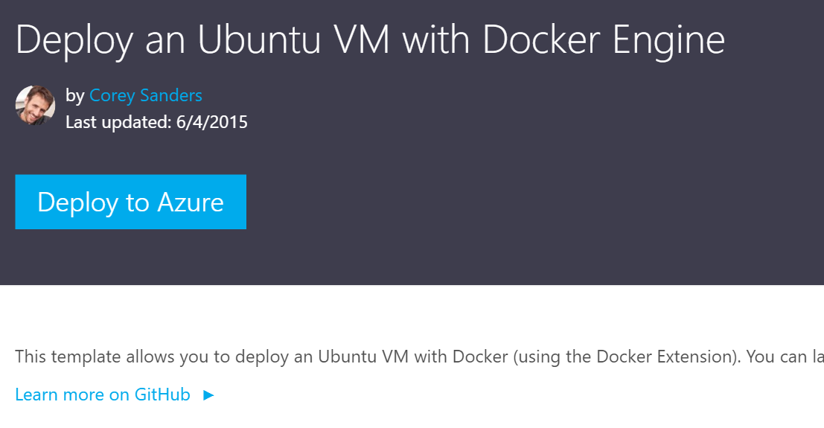

This starts a custom deployment based on this Microsoft template, written by Corey Sanders. Just fill out the required parameters and click create.

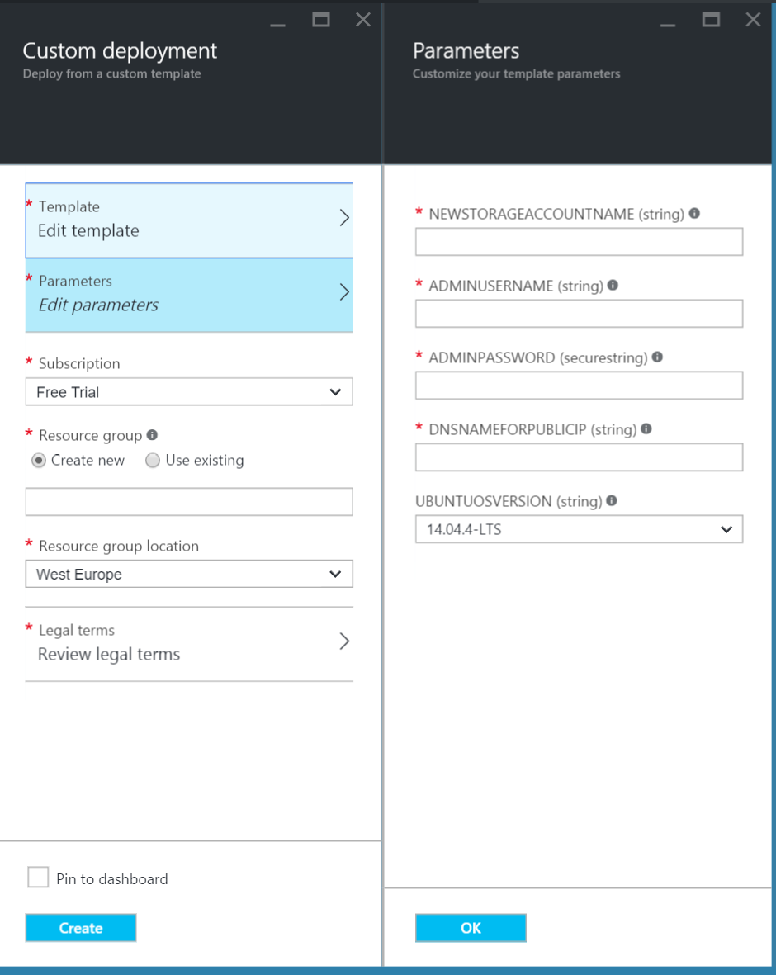

**When the docker VM host has been deployed correctly, please continue to the step : Get Started with Docker Engine for Linux.**

## ****Alternatively use the Azure CLI to deploy this Docker Host environment****

You can use the Azure CLI to deploy this host with the azure group command, making use of the same template on github.

First delete the resource group created in the previous exercises.

* Important: all resources you previously created will be lost.

View all resource groups in your subscription

azure group list

Then delete the specific resource group:

azure group delete [resource group name]

## ****Create the docker host using the CLI****

**azure group create --name accelerate[uniqueid] --location "West Europe" --template-uri** <https://raw.githubusercontent.com/Azure/azure-quickstart-templates/master/docker-simple-on-ubuntu/azuredeploy.json>

This process will take a few minutes to complete.

# Get Started with Docker Engine for Linux

By following this getting started, you’ll learn fundamental Docker features by performing some simple tasks. You’ll learn how to:

* install Docker Engine
* run a software image in a container
* browse for an image on Docker Hub
* create your own image and run it in a container
* create a Docker Hub account and an image repository
* create an image of your own
* push your image to Docker Hub for others to use

These steps take approximately 45 minutes to complete.

### Make sure you understand…

This getting started uses Docker Engine CLI commands entered on the command line of a terminal window. You don’t need to be a wizard at the command line, but you should be familiar with how to open your favorite shell or terminal, and run basic commands in that environment. It helps (but isn’t required) to know how to navigate a directory tree, manipulate files, list running process, and so forth.

Step 1: Verify Docker is installed correctly.

Docker run hello-world

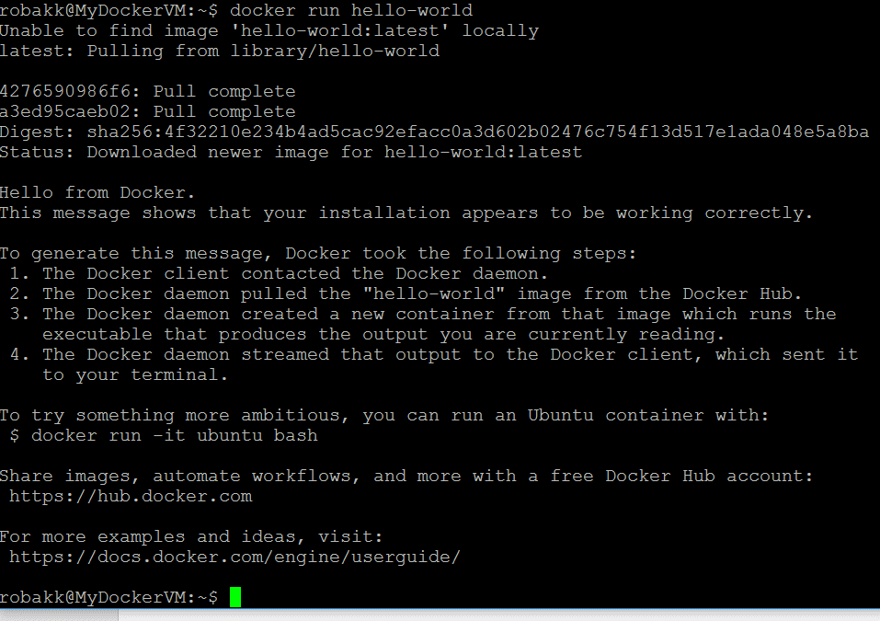

At this point, you have successfully installed Docker. Leave the terminal window open.

# Learn about images & containers

Docker Engine provides the core Docker technology that enables images and containers. As the last step in your installation, you ran the Engine docker run hello-world command. With this one command, you completed the core tasks to using Engine. The command you ran had three parts.

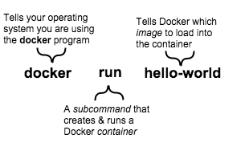

A container is a stripped-to-basics version of a Linux operating system. An image is software you load into a container. When you ran the command, the Engine software:

* checked to see if you had the **hello-world** software image
* downloaded the image from the Docker Hub (more about the hub later)
* loaded the image into the container and “ran” it

Depending on how it was built, an image might run a simple, single command and then exit. This is what Hello-World did.

A Docker image, though, is capable of much more. An image can start software as complex as a database, wait for you (or someone else) to add data, store the data for later use, and then wait for the next person.

Who built the **hello-world** software image though? In this case, Docker did but anyone can. Docker Engine lets people (or companies) create and share software through Docker images. Using Docker Engine, you don’t have to worry about whether your computer can run the software in a Docker image — a Docker container can always run it.

See, that was quick wasn’t it? Now, you are ready to do some really fun stuff with Docker. Go on to the next part

# Find and run the whalesay image

People all over the world create Docker images. You can find these images by browsing the Docker Hub. In this next section, you’ll do just that to find the image to use in the rest of this getting started.

## Step 1: Locate the whalesay image

Open your browser and go to <https://hub.docker.com>

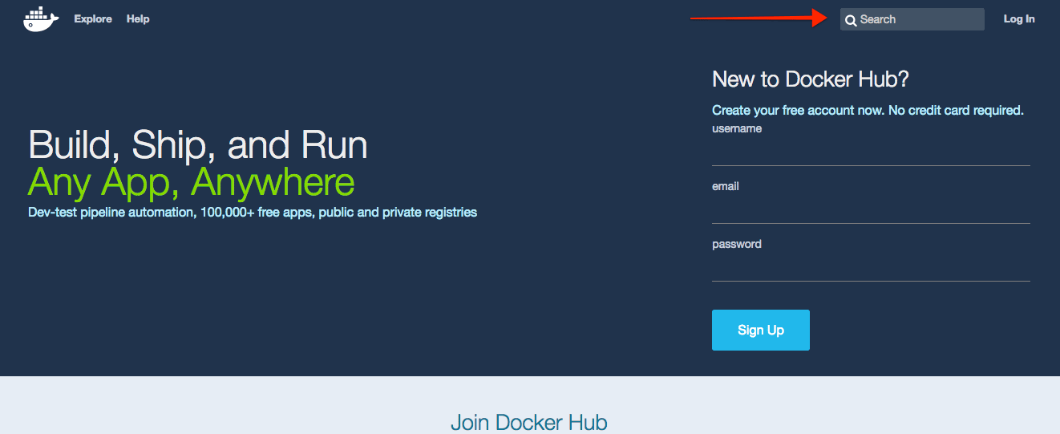

The Docker Hub contains images from individuals like you and official images from organizations like RedHat, IBM, Google, and a whole lot more.

1. Click Browse & Search.
2. The browser opens the search page. Enter the word whalesay in the search bar.
3. 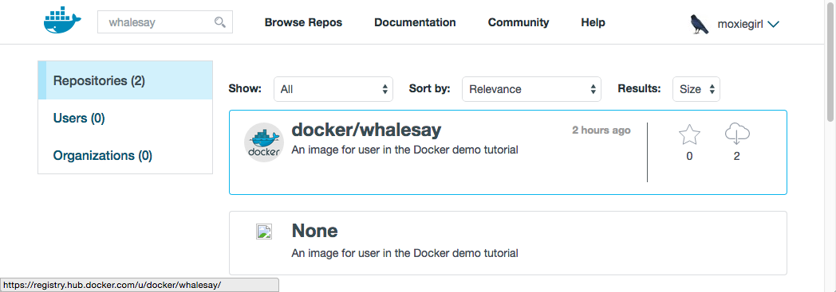Click on the **docker/whalesay** image in the results.
4. The browser displays the repository for the **whalesay** image.

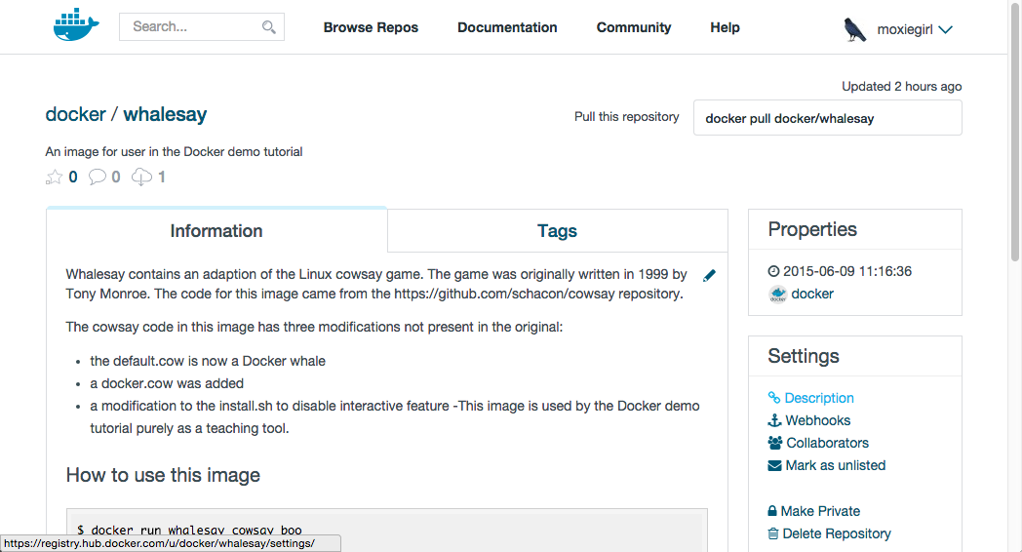

Each image repository contains information about an image. It should include information such as what kind of software the image contains and how to use it. You may notice that the **whalesay** image is based on a Linux distribution called Ubuntu. In the next step, you run the **whalesay** image on your machine.

## Step 2: Run the whalesay image

Put your cursor in your terminal window at the **$** prompt.

Type the **docker run docker/whalesay cowsay boo** command and press RETURN.

This command runs the **whalesay** image in a container. Your terminal should look like the following:

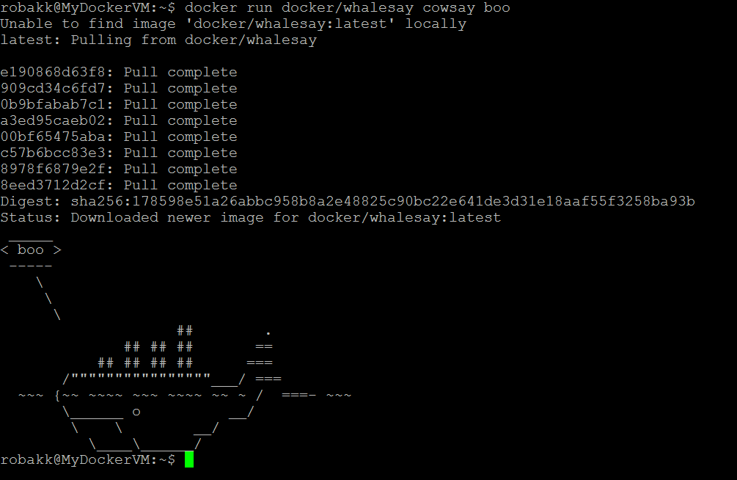

The first time you run a software image, the docker command looks for it on your local system. If the image isn’t there, then docker gets it from the hub.

While still in the terminal, type docker images command and press RETURN.

The command lists all the images on your local system. You should see docker/whalesay in the list.

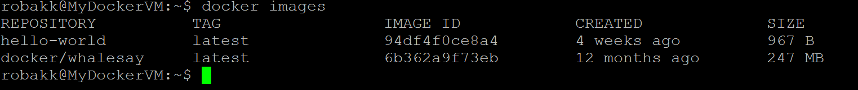

When you run an image in a container, Docker downloads the image to your computer. This local copy of the image saves you time. Docker only downloads the image again if the image’s source changes on the hub. You can, of course, delete the image yourself. You’ll learn more about that later. Let’s leave the image there for now because we are going to use it later.

Try running the **whalesay** image again with a word or phrase. Try a long or short phrase.

# Build your own image

The **whalesay** image could be improved. It would be nice if you didn’t have to think of something to say. And you type a lot to get **whalesay** to talk.

docker run docker/whalesay cowsay boo-boo

In this next section, you will improve the **whalesay** image by building a new version that “talks on its own” and requires fewer words to run.

## Step 1: Write a Dockerfile

In this step, you use your favorite text editor to write a short Dockerfile. A Dockerfile describes the software that is “baked” into an image. It isn’t just ingredients tho, it can tell the software what environment to use or what commands to run. Your recipe is going to be very short.

1. Go back to your terminal window.
2. Make a new directory by typing mkdir mydockerbuild and pressing RETURN.

This directory serves as the “context” for your build. The context just means it contains all the things you need to build your image.

1. Change to your new directory $ cd mydockerbuild

Right now the directory is empty.

1. Create a text file called Dockerfile in your current directory.You can use any text editor for example, vi or nano to do this. Nano Dockerfile

Add a line to the file like this:

FROM docker/whalesay:latest

The FROM keyword tells Docker which image your image is based on. Whalesay is cute and has the cowsay program already, so we’ll start there.

Now, add the fortunes program to the image.

RUN apt-get -y update && apt-get install -y fortunes

The fortunes program has a command that prints out wise sayings for our whale to say. So, the first step is to install it. This line installs the software into the image.

Once the image has the software it needs, you instruct the software to run when the image is loaded.

CMD /usr/games/fortune -a | cowsay

This line tells the fortune program to pass a nifty quote to the cowsay program.

Check your work, your file should look like this:

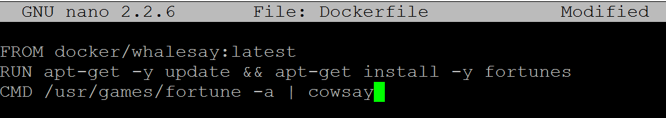

FROM docker/whalesay:latest

RUN apt-get -y update && apt-get install -y fortunes

CMD /usr/games/fortune -a | cowsay

Save and close your Dockerfile. (CTRL-X in Nano)

At this point, you have all your software ingredients and behaviors described in a Dockerfile. You are now ready to build a new image.

## Step 2: Build an image from your Dockerfile

Now, build your new image by typing the docker build -t docker-whale . command in your terminal (don’t forget the . period).

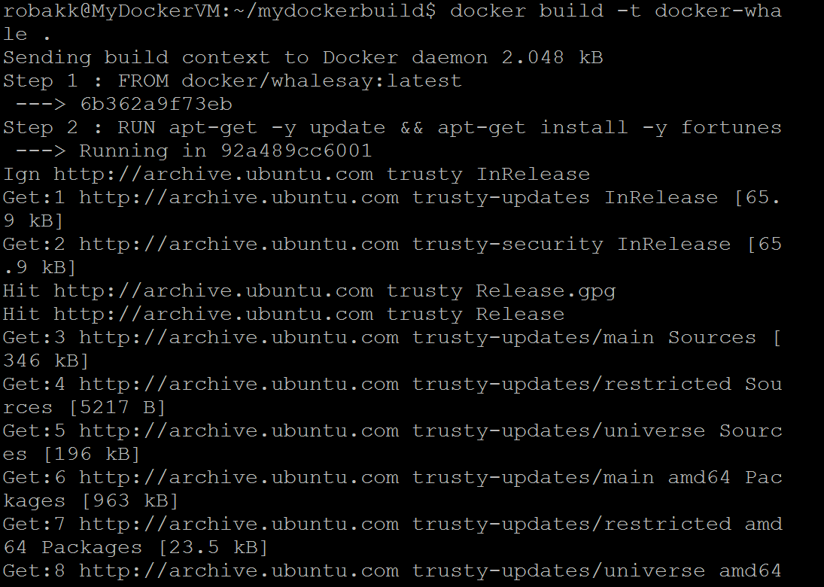

The command takes several seconds to run and reports its outcome. Before you do anything with the new image, take a minute to learn about the Dockerfile build process.

Step 3: Learn about the build process

The **docker build -t docker-whale .** command takes the **Dockerfile** in the current directory, and builds an image called**docker-whale** on your local machine. The command takes about a minute and its output looks really long and complex. In this section, you learn what each message means.

First Docker checks to make sure it has everything it needs to build.

Sending build context to Docker daemon 158.8 MB

Then, Docker loads with the **whalesay** image. It already has this image locally as you might recall from the last page. So, Docker doesn’t need to download it.

Step 0 : **FROM** docker/whalesay:latest

---> fb434121fc77

Docker moves onto the next step which is to update the **apt-get** package manager. This takes a lot of lines, no need to list them all again here.

Step 1 : RUN apt-get -y **update** && apt-**get** **install** -y fortunes

*---> Running in 27d224dfa5b2*

Ign **http**://**archive**.ubuntu.com trusty InRelease

Ign **http**://**archive**.ubuntu.com trusty-updates InRelease

Ign **http**://**archive**.ubuntu.com trusty-**security** InRelease

Hit **http**://**archive**.ubuntu.com trusty **Release**.gpg

....snip...

**Get**:15 **http**://**archive**.ubuntu.com trusty-**security**/**restricted** amd64 Packages [14.8 kB]

**Get**:16 **http**://**archive**.ubuntu.com trusty-**security**/universe amd64 Packages [134 kB]

Reading **package** lists...

*---> eb06e47a01d2*

Then, Docker installs the new **fortunes** software.

Removing intermediate container e2a84b5f390f

Step 2 : RUN apt-get **install** -y fortunes

*---> Running in 23aa52c1897c*

Reading **package** lists...

Building dependency tree...

Reading state information...

The **following** extra packages will be installed:

fortune-**mod** fortunes-**min** librecode0

Suggested packages:

x11-utils bsdmainutils

The **following** **NEW** packages will be installed:

fortune-**mod** fortunes fortunes-**min** librecode0

0 upgraded, 4 newly installed, 0 **to** remove **and** 3 **not** upgraded.

Need **to** **get** 1961 kB **of** archives.

**After** this operation, 4817 kB **of** additional disk **space** will be used.

**Get**:1 **http**://**archive**.ubuntu.com/ubuntu/ trusty/**main** librecode0 amd64 3.6-21 [771 kB]

...snip......

Setting up fortunes (1:1.99.1-7) ...

Processing **triggers** **for** libc-**bin** (2.19-0ubuntu6.6) ...

*---> c81071adeeb5*

Removing intermediate **container** 23aa52c1897c

Finally, Docker finishes the build and reports its outcome.

Step 3 : CMD /usr/games/fortune -a | cowsay

---> Running **in** a8e6faa88df3

---> 7d9495d03763

Removing intermediate container a8e6faa88df3

Successfully built 7d9495d03763

### Step 4: Run your new docker-whale

In this step, you verify the new images is on your computer and then you run your new image.

If it isn’t already there, place your cursor at the prompt in your terminal window.

Type docker images and press RETURN.

This command, you might remember, lists the images you have locally.

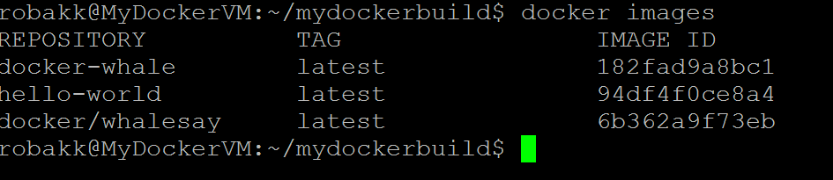

Run your new image by typing docker run docker-whale and pressing RETURN.

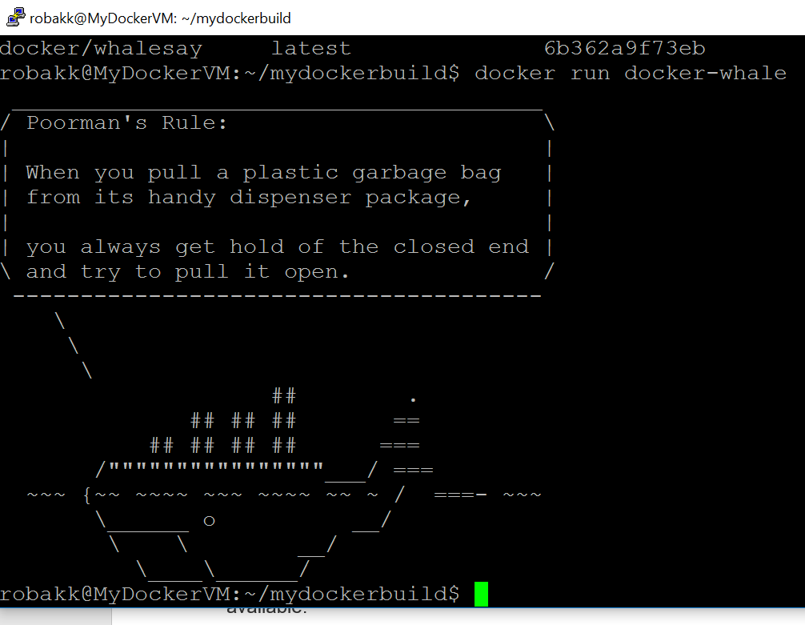

As you can see, you’ve made the whale a lot smarter. It finds its own things to say and the command line is a lot shorter! You may also notice that Docker didn’t have to download anything. That is because the image was built locally and is already available.

# Create a Docker Hub account & repository

You’ve built something really cool, you should share it. In this next section, you’ll do just that. You’ll need a Docker Hub account. Then, you’ll push your image up to it so other people with Docker Engine can run it.

## Step 1: Sign up for an account

Use your browser to navigate to [the Docker Hub signup page](https://hub.docker.com/?utm_source=getting_started_guide&utm_medium=embedded_Linux&utm_campaign=create_docker_hub_account).

Your browser displays the page.

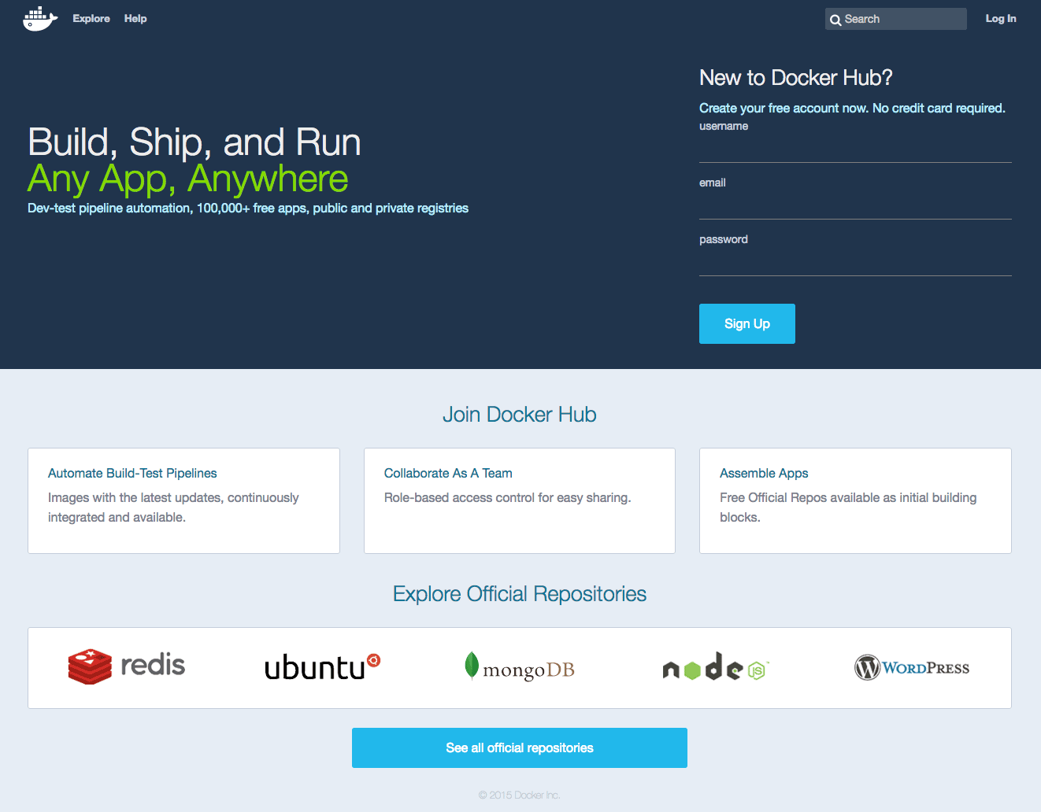

1. Fill out the form on the signup page.

Docker Hub is free. Docker does need a name, password, and email address.

1. Press **Signup**.

The browser displays the welcome to Docker Hub page.

## Step 2: Verify your email and add a repository

Before you can share anything on the hub, you need to verify your email address.

1. Open your email inbox.

Look for the email titled **Please confirm email for your Docker Hub account**.

1. If you don’t see the email, check your Spam folder or wait a moment for the email to arrive.
2. Open the email and click the **Confirm Your Email** button.
3. The browser opens Docker Hub to your profile page.
4. Choose **Create Repository**.

The browser opens the **Create Repository** page.

1. Provide a Repository Name and Short Description.
2. Make sure Visibility is set to **Public**.

When you are done, your form should look similar to the following:

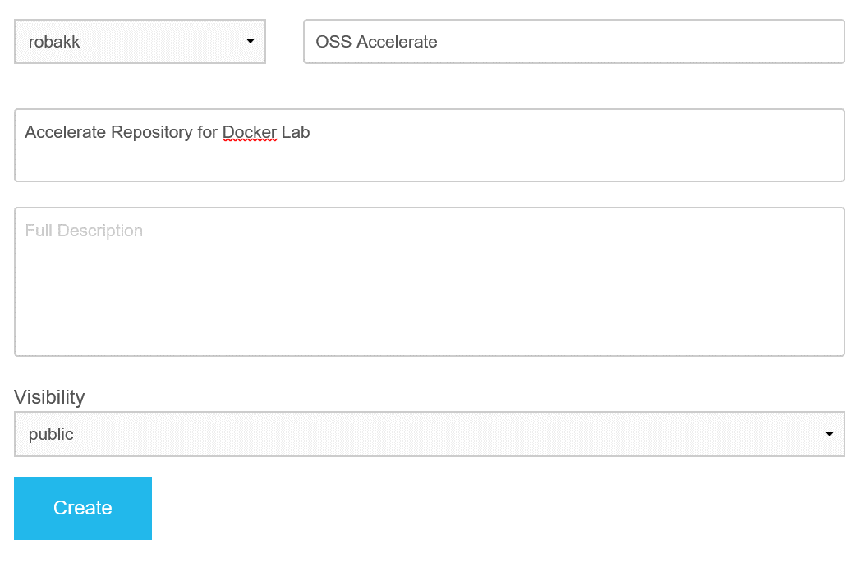

1. Press Create when you are done.

Docker Hub creates your new repository.

# Tag, push, and pull your image

In this section, you tag and push your **docker-whale** image to your newly created repository. When you are done, you test the repository by pulling your new image.

## Step 1: Tag and push the image

1. Go back to your terminal.
2. List the images you currently have by typing docker images



1. Find the **IMAGE ID** for your **docker-whale** image.

In this example, the id is **182fad9a8bc1**.

Notice that currently, the **REPOSITORY** shows the repo name **docker-whale** but not the namespace. You need to include the **namespace** for Docker Hub to associate it with your account. The **namespace** is the same as your Docker Hub account name. You need to rename the image to **YOUR_DOCKERHUB_NAME/docker-whale**.

Use **IMAGE ID** and the **docker tag** command to tag your **docker-whale** image.

The command you type looks like this:

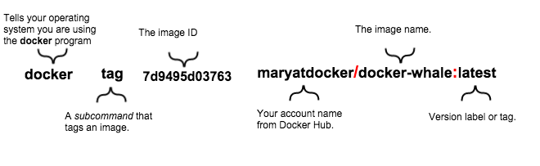

Of course, your account name will be your own. So, you type the command with your image’s ID and your account name and press RETURN.

$ docker tag 7d9495d03763 [username]/docker-whale:latest

1. Type the **docker images** command again to see your newly tagged image.



1. Use the **docker login** command to log into the Docker Hub from the command line.

The format for the login command is: docker login –username=yourhubusername



1. Use the **docker push** command to push your image to your new repository.



1. Return to your profile on Docker Hub to see your new image.



## Step 2: Pull your new image

In this last section, you’ll pull the image you just pushed to hub. Before you do that though, you’ll need to remove the original image from your local machine. If you left the original image on your machine, Docker would not pull from the hub — why would it? The two images are identical.

1. Place your cursor at the prompt in your terminal window.
2. Type **docker images** to list the images you currently have on your local machine.
3. To make a good test, you need to remove the **user/docker-whale** and **docker-whale** images from your local system. Removing them forces the next **docker pull** to get the image from your repository.
4. Use the **docker rmi** to remove the images.
5. You can use an ID or the name to remove an image.



1. Pull and load a new image from your repository using the **docker run** command. The command you type should include your username from Docker Hub. docker run yourusername/docker-whale
2. Since the image is no longer available on your local system, Docker downloads it.



You’ve done a lot, you’ve done all of the following fundamental Docker tasks.

* installed Docker
* run a software image in a container
* located an interesting image on Docker Hub
* run the image on your own machine
* modified an image to create your own and run it
* create a Docker Hub account and repository
* pushed your image to Docker Hub for others to share